**Data Engineering Assignment – 8**

**METHODS TO READ A CSV FILE INTO PYTHON:**

* Using csv.reader

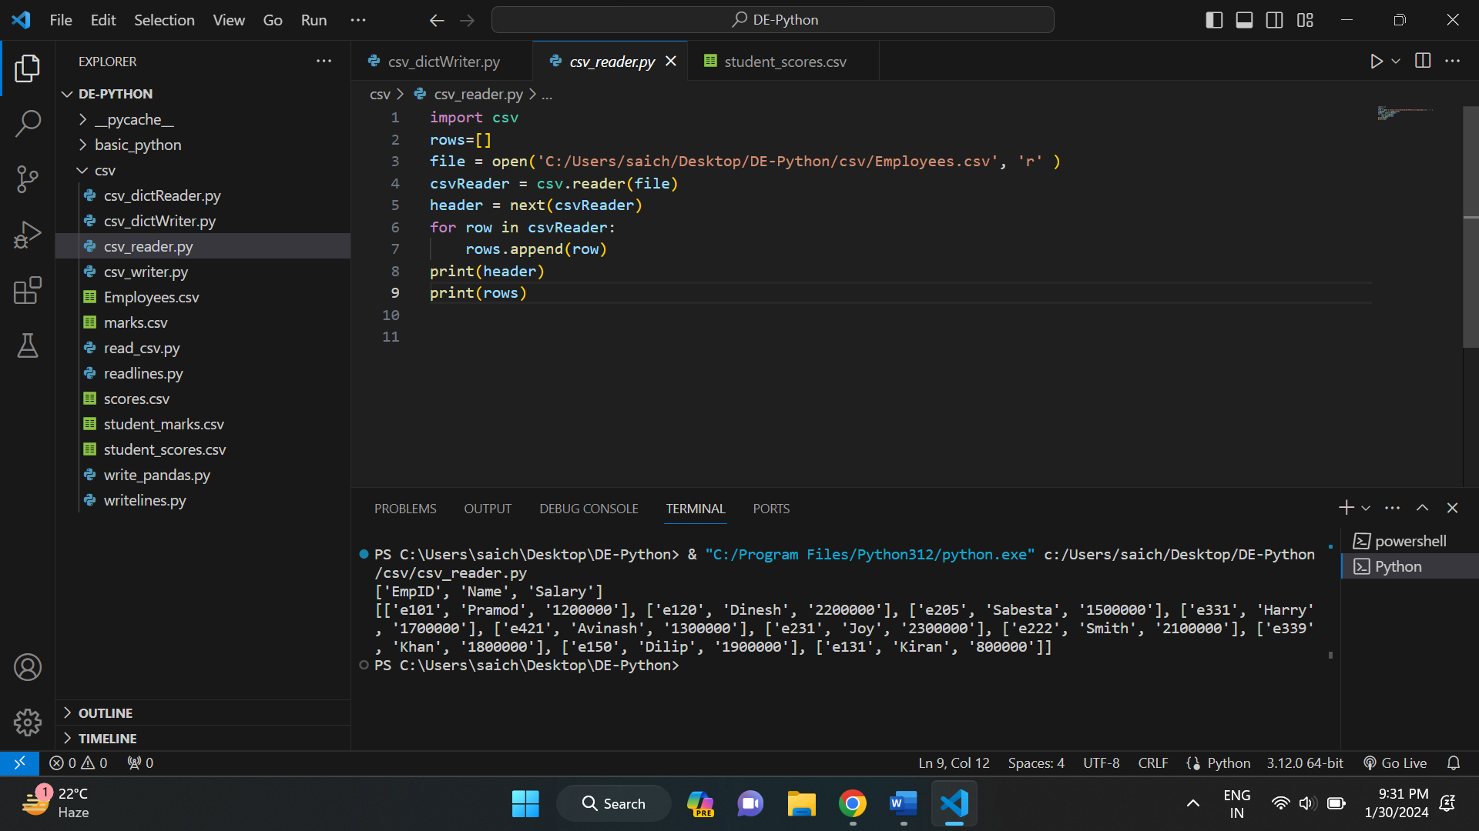

* Using .readlines() function:

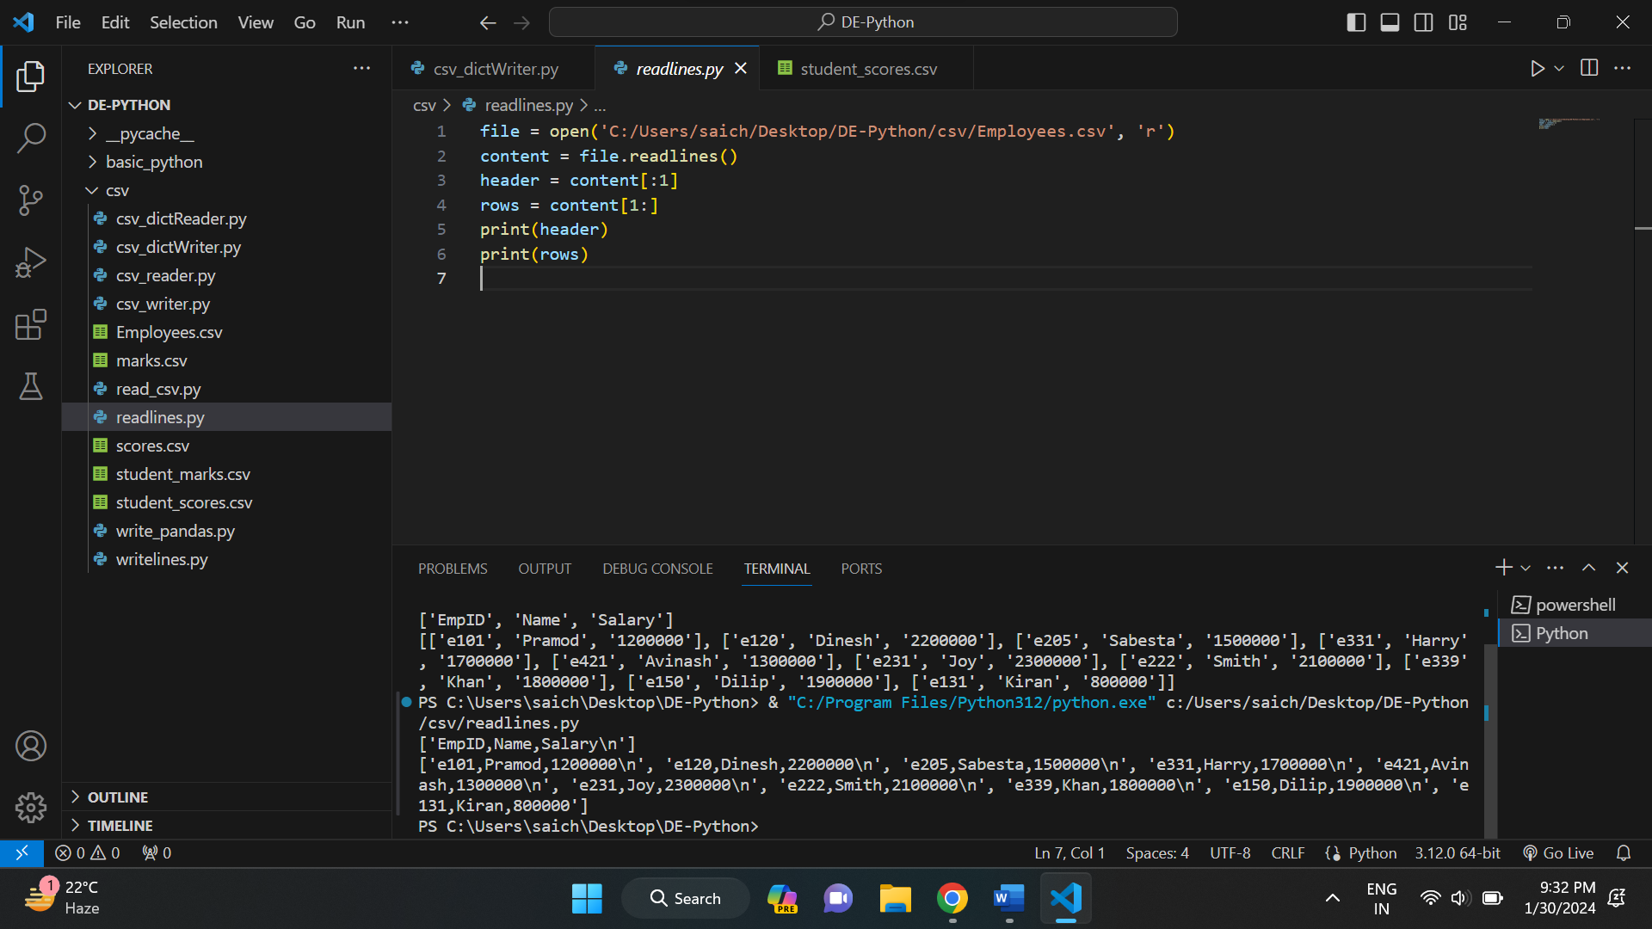

* Using pandas library:

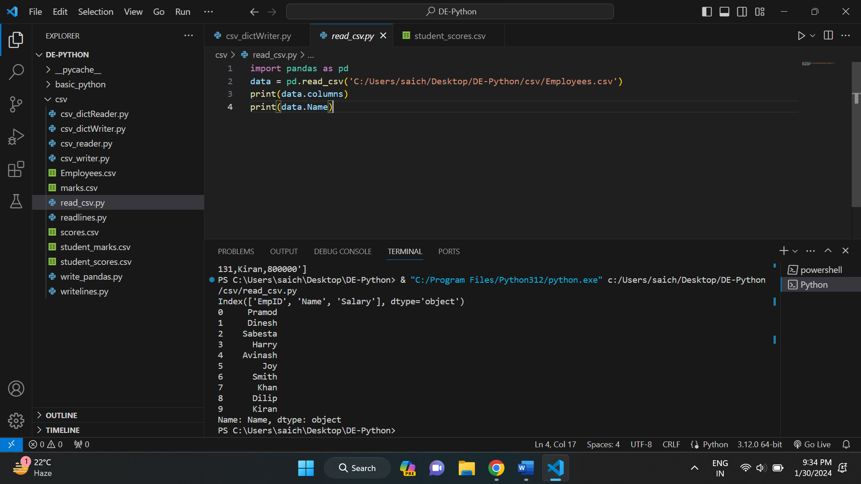

* Using csv.DictReader()

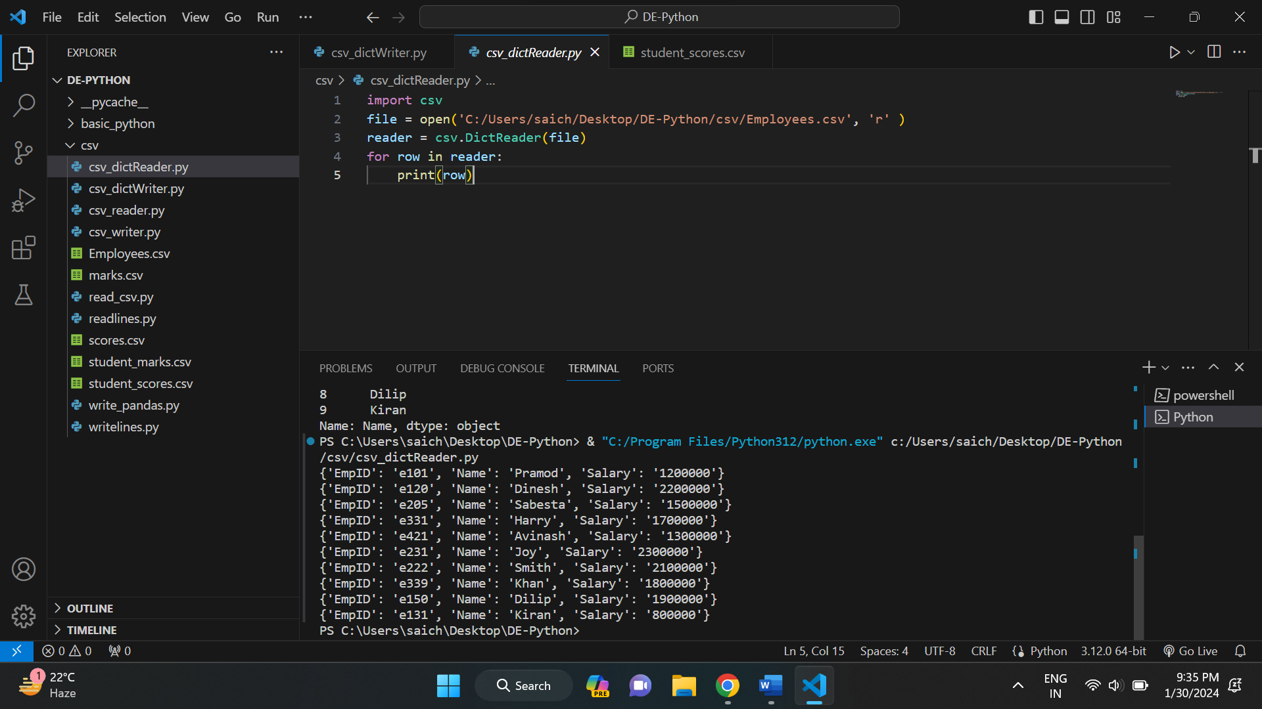

**METHODS TO WRITE INTO PYTHON CSV:**

* Using csv.writer:

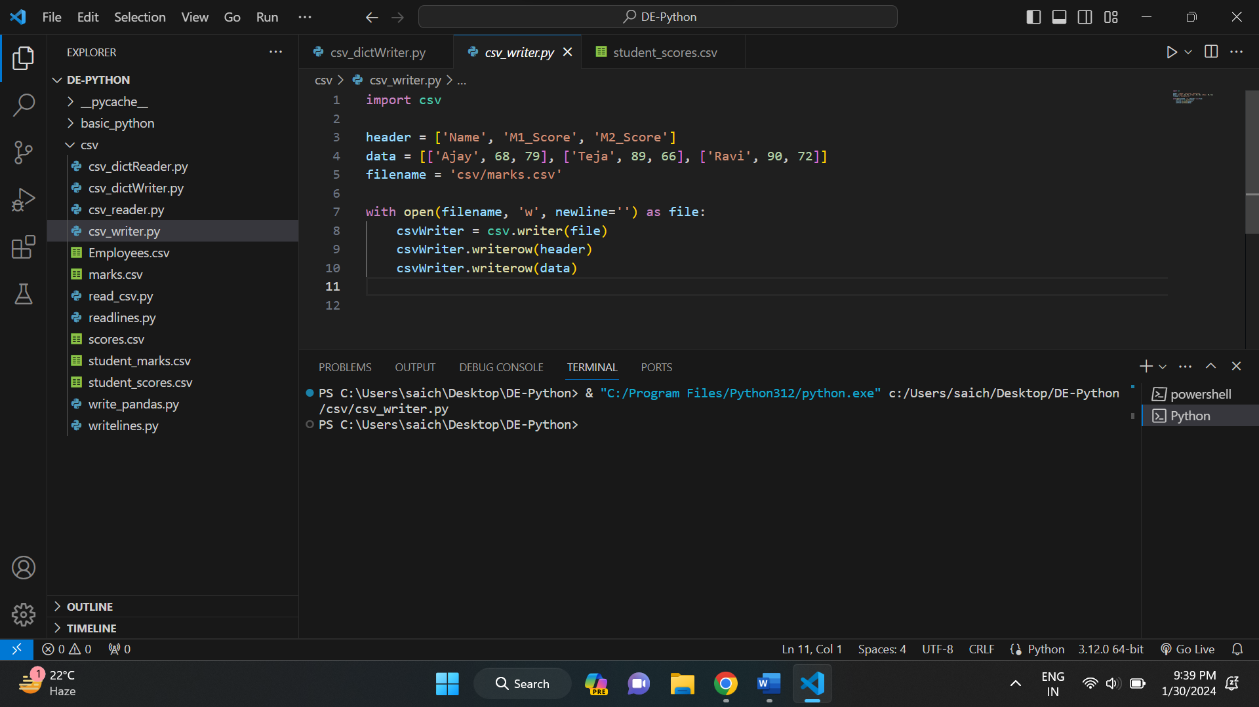

And below is the created marks.csv file.

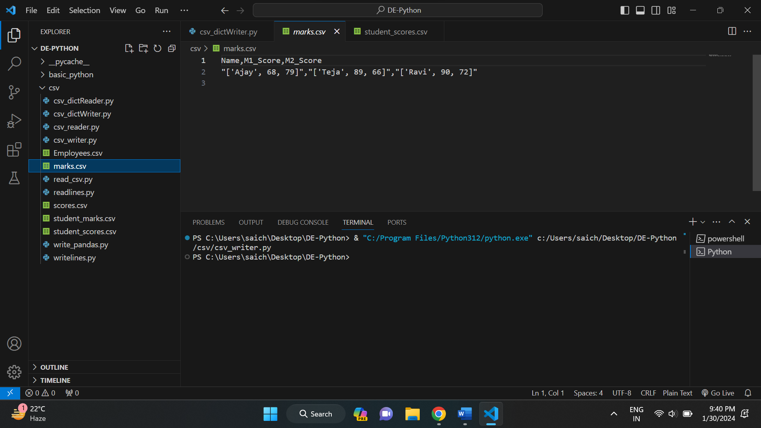

* Using .writelines()

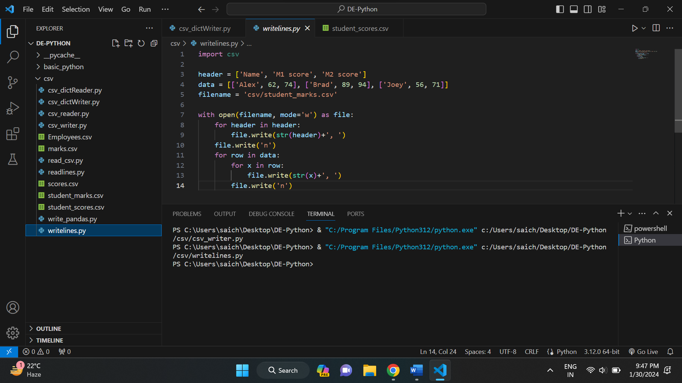

And below is the created student_marks.csv file.

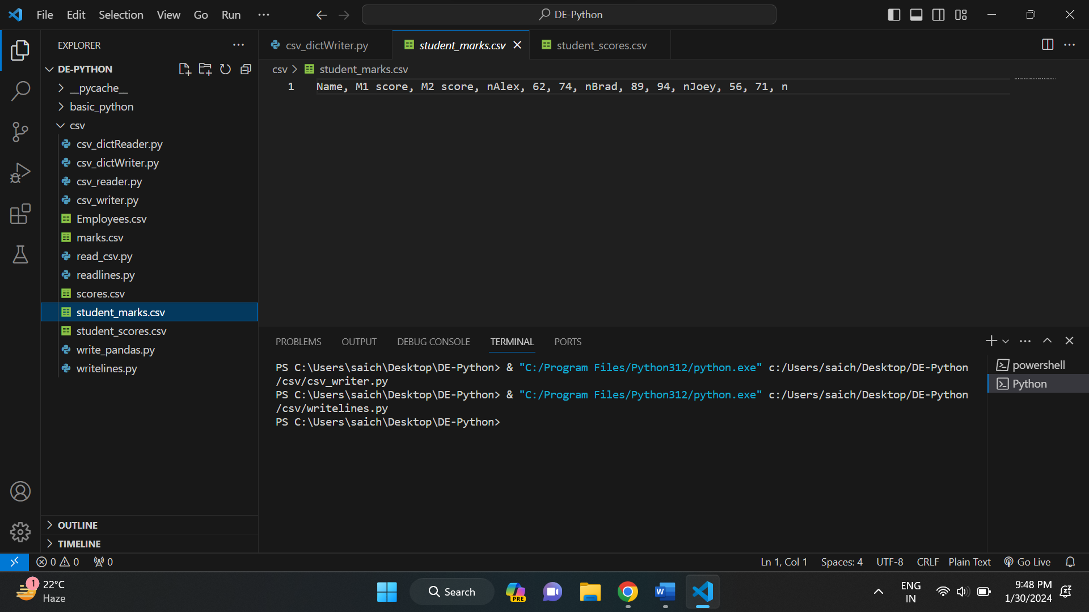

* Using pandas:

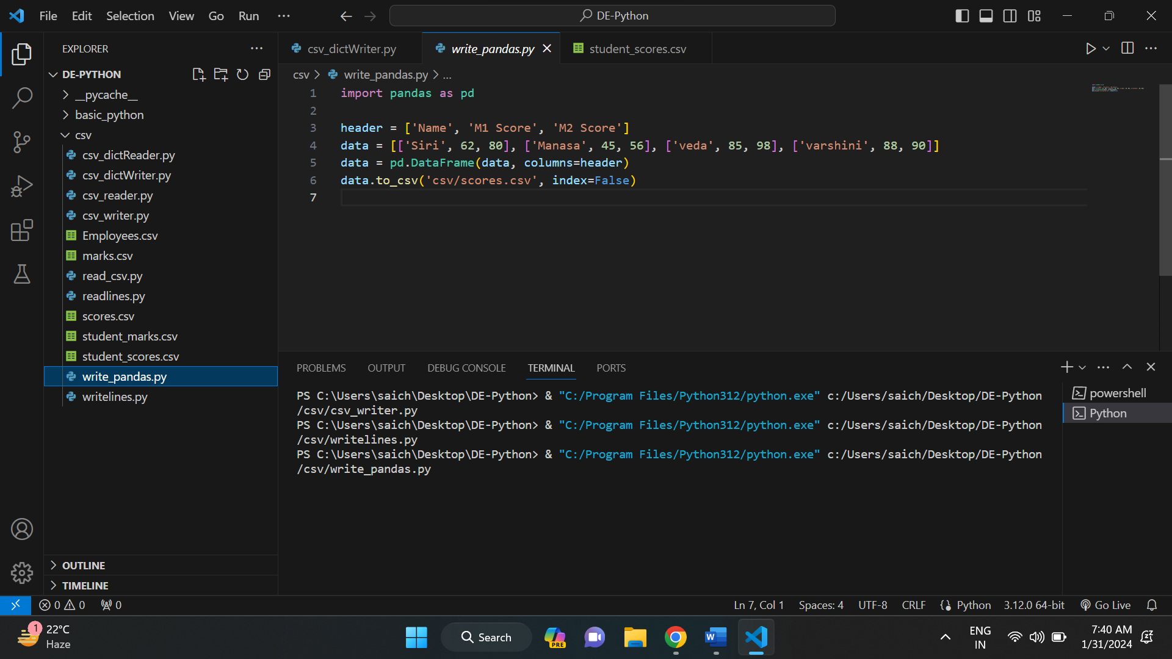

And below is the created scores.csv file.

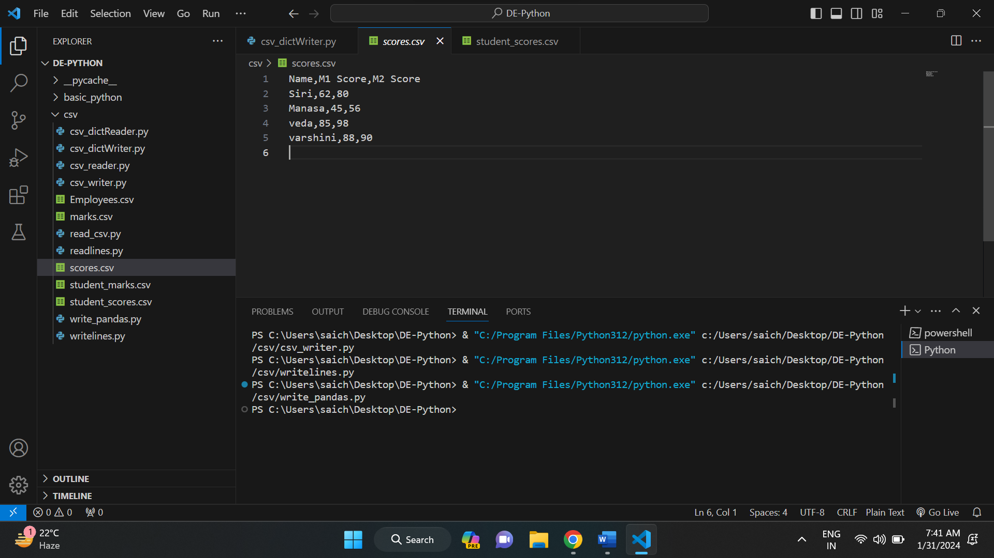

* Using csv.DictWriter

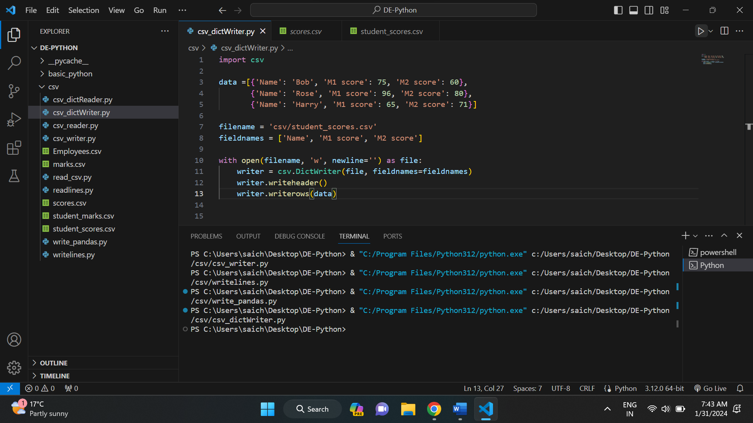

And below is the created student_scores.csv file.

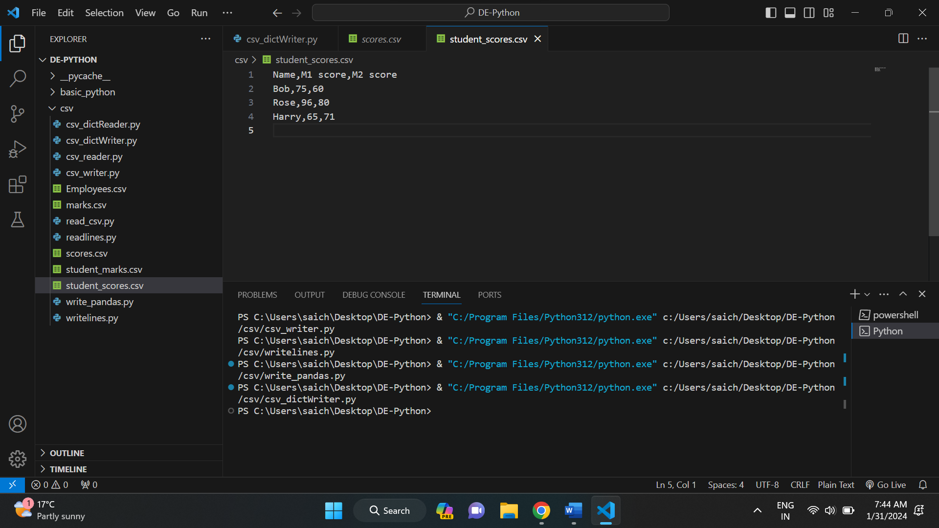

**LAMBDA FUNCTIONS IN PYTHON:**

Python Lambda Functions are anonymous functions means that the function is without a name. As we already know the def keyword is used to define a normal function in Python. Similarly, the lambda keyword is used to define an anonymous function in Python.

Below are the some of the examples of lambda functions in python.

Example: 1

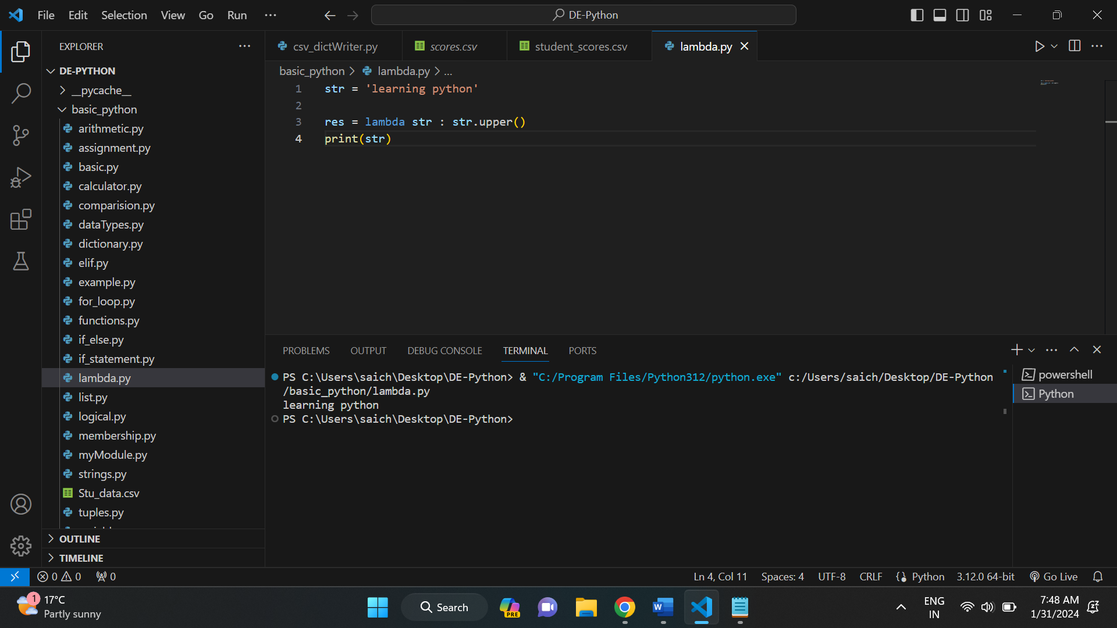

In the above example, string str is converted into upper case using lambda function. It has no def keyword. It has online parameters and expression and defined using lambda keyword.

Example: 2

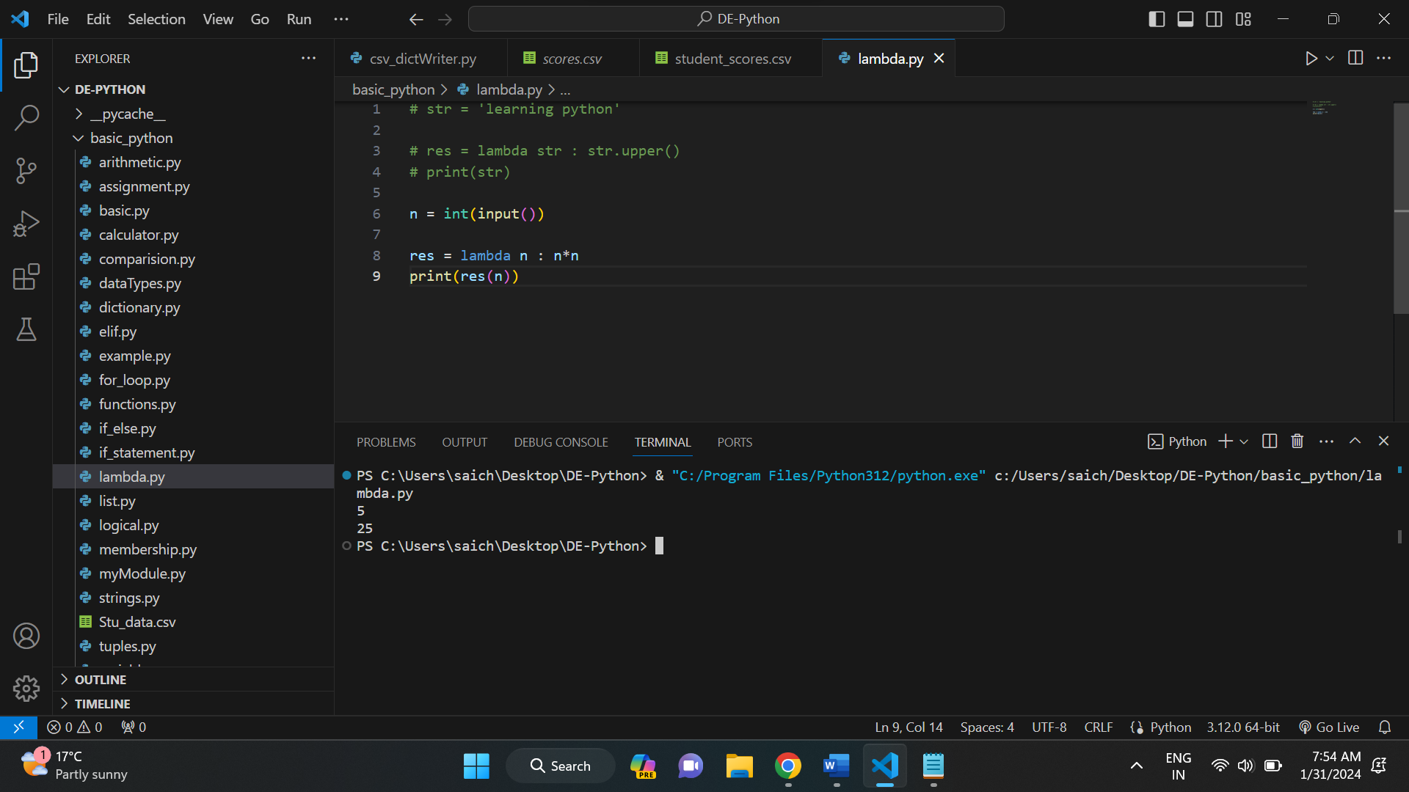

**FILTER FUNCTION:**

It constructs an iterator from elements of iterable for which the function returns true. It takes two parameters: a function and an iterable. The function is applied to every element of the iterable. If the function returns True, the element is included in the result; otherwise, it is excluded.

Example:

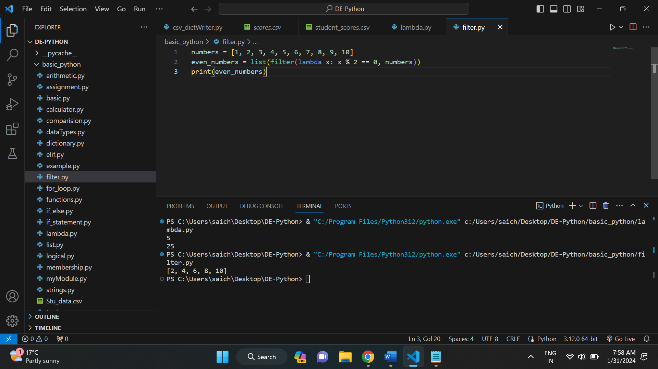

**MAP FUNCTION:**

It applies the function to every item in the iterable and returns an iterator of the results. It takes two parameters: a function and an iterable. The function is applied to each element in the iterable, and the result is returned in the form of an iterator.

Example:

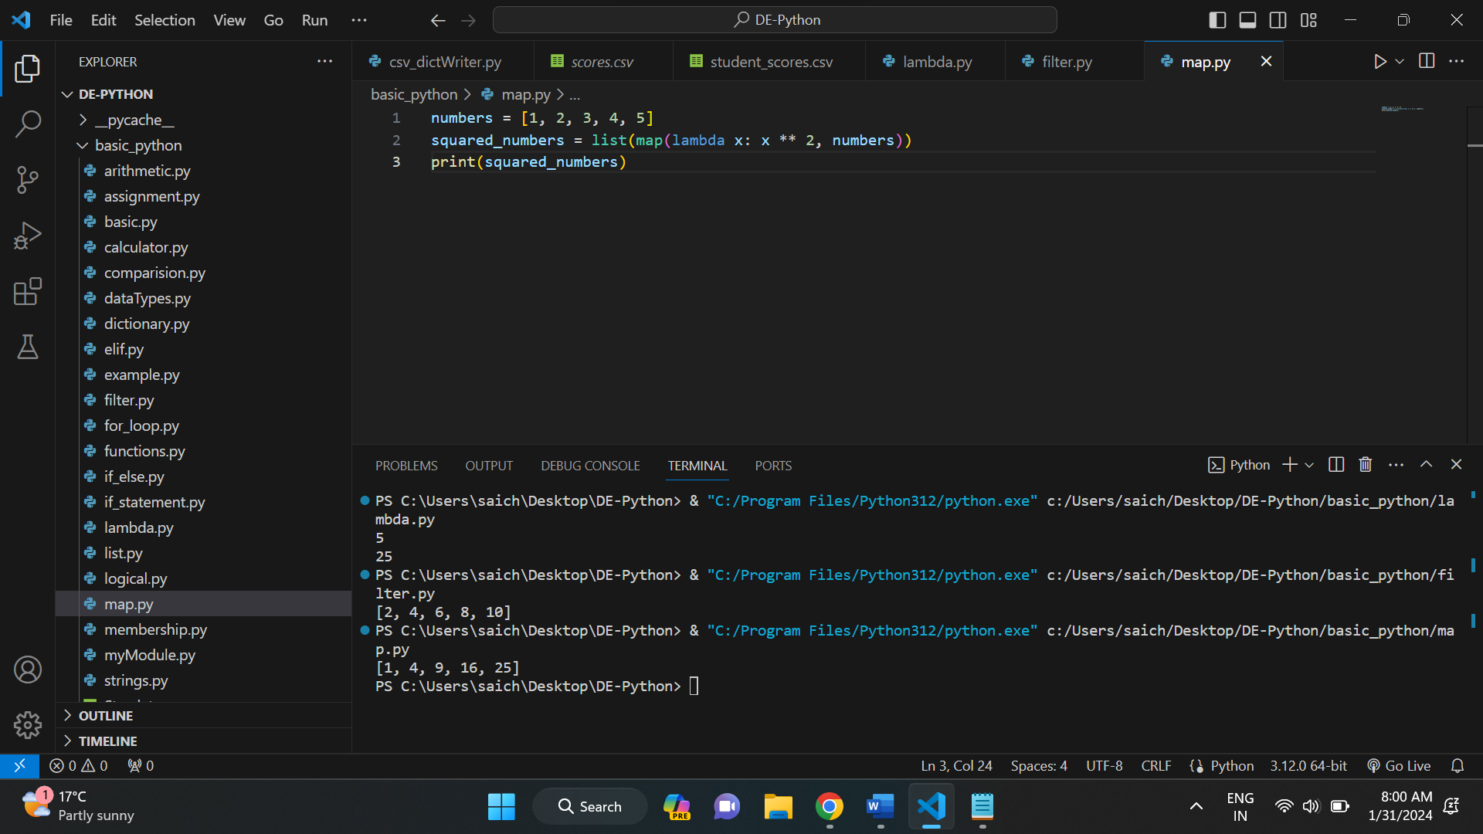

**REDUCE FUNCTION:**

It applies the function of two arguments cumulatively to the items of iterable, from left to right, so as to reduce the iterable to a single value. It's available in the functools module in Python 3. The function is applied to the first two elements of the iterable, then to the result and the next element, and so on.

Example:

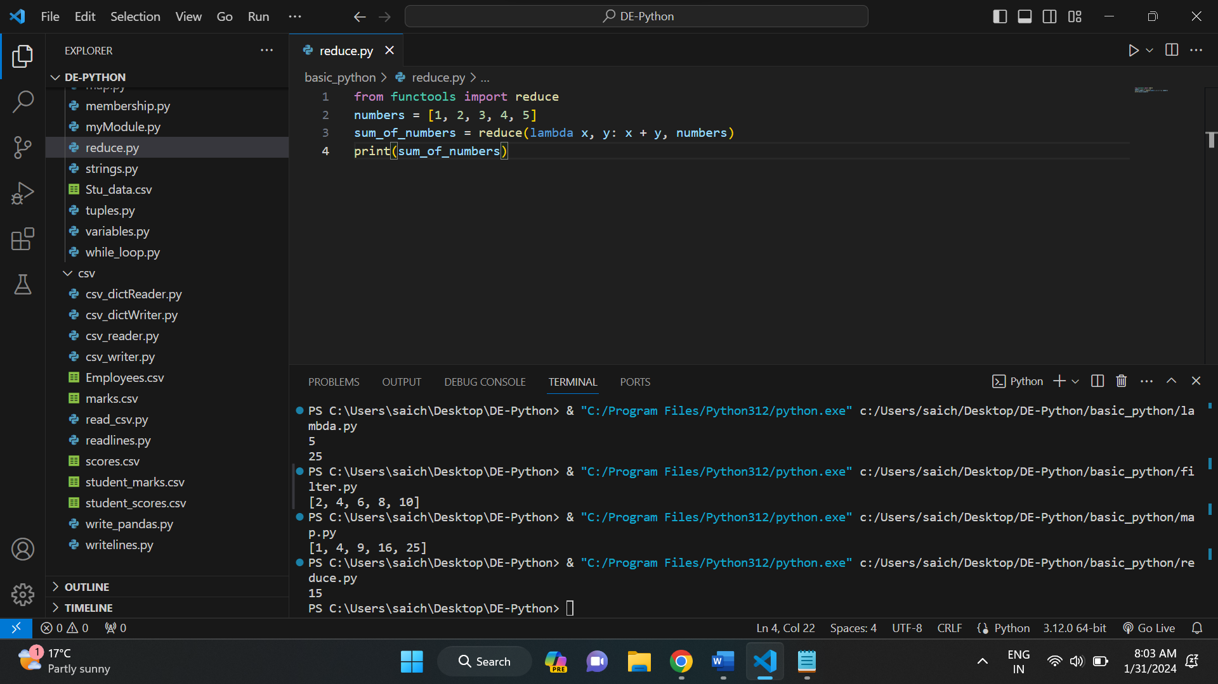

**PYTHON – ARBITRARY ARGUMENTS:**

You may want to define a function that is able to accept arbitrary or variable number of arguments. Moreover, the arbitrary number of arguments might be positional or keyword arguments.

* An argument prefixed with a single asterisk * for arbitrary positional arguments.
* An argument prefixed with two asterisks ** for arbitrary keyword arguments.

Example: 1

This an example of arbitrary or variable length positional arguments.

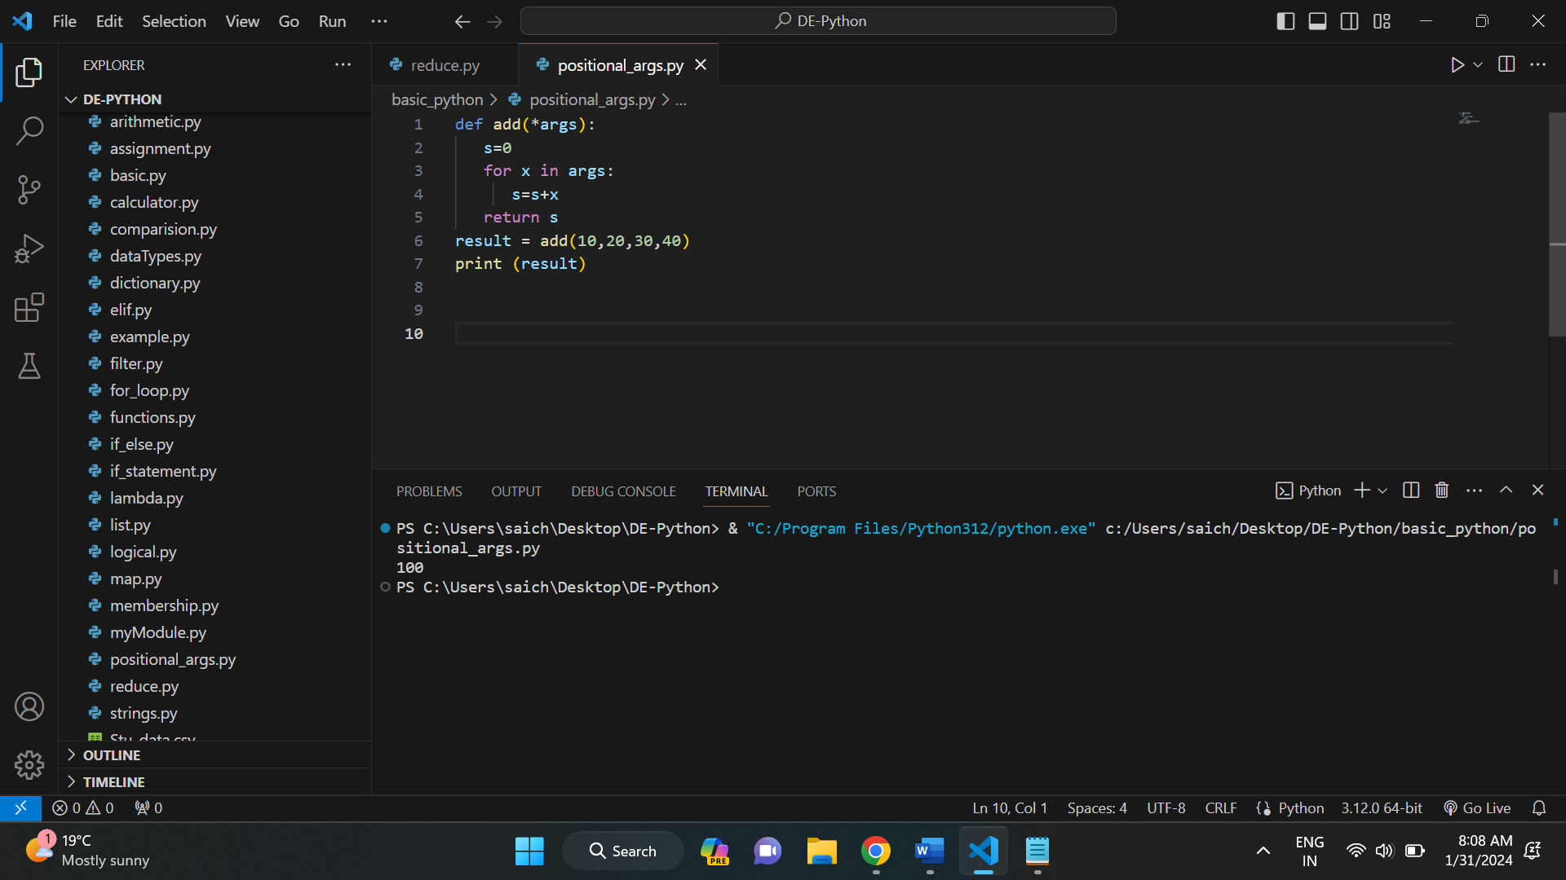

Example: 2

This is an example of a function with arbitrary keyword arguments.

